Use Case approach — Social-Media Analytics & Voice-of-Customer Insights

1. Overview
This document describes the updated system architecture for the Social-Media Analytics & Voice-of-Customer Insights project. It replaces the earlier storage-only pipeline view with the current design, which adds an orchestration layer (FastAPI), a combined sentiment/intent/clustering processing block, a retrieval-augmented generation (RAG) path, and a GenAI agent that produces the final summaries and recommendations shown on the dashboard and chatbot.
The goal of this note is to walk through the diagram in plain language — what each block does, what technology sits behind it, and how data moves from raw input to a final answer — so the flow is easy to review without needing a live walkthrough.

2. Architecture Diagram

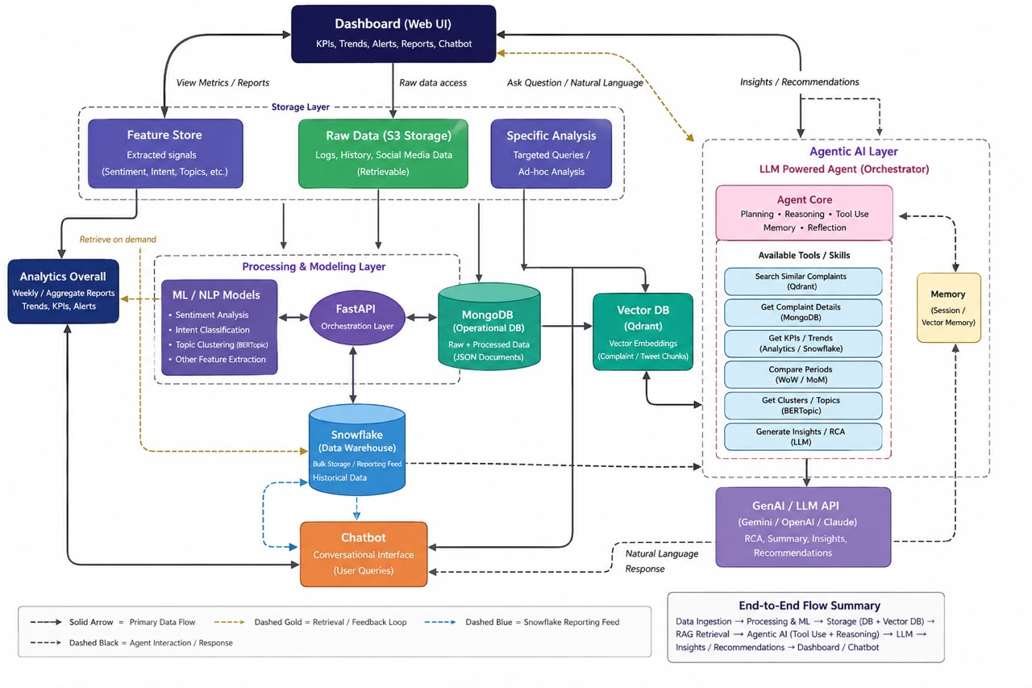
Figure 1: Updated end-to-end architecture — Dashboard, storage, processing, retrieval, and generation layers.

3. How the System Works — Step by Step
- Entry point: The Dashboard is where raw data enters the system and where final results (analytics, summaries) are shown back to the user.
- Raw data intake: Incoming data is written to storage (S3-style) as Raw Data — kept as history/logs so it can always be retrieved again later if needed. From this raw data, two things are derived: Feature (extracted signals used for analytics) and Specific Analysis (used when a targeted query comes in, rather than a general one).
- Overall analytics: The Feature output feeds Analytics Overall, which produces aggregate views such as weekly summary reports. This block also receives updates back from the processing layer and the GenAI agent, so it stays current as new data and answers are generated.
- Structured storage: Raw Data is also written to a DB (structured store). This DB is the shared reference point that the processing layer reads from and writes back to.
- Processing layer (FastAPI + Algorithm/LLM): This is the orchestration core. FastAPI exposes the processing logic as callable endpoints. The Algorithm/LLM block underneath performs sentiment classification, intent detection, and topic clustering. It reads from and writes to the DB, can pull raw data back out of storage on demand (the retrieval loop shown with the dashed gold arrow).
- Snowflake stores the cleaned and structured conversation data for large-scale analytics and reporting. It supports KPI calculations, trend analysis, recurring-issue analysis, and user-selected date-range reports, providing the data needed to generate charts, summaries, and AI-driven recommendations. Embedding & retrieval (Vector DB → RAG): In parallel, the DB feeds a Vector DB (Qdrant), where data is embedded and stored for semantic search. When a query needs to be matched against existing data, RAG retrieves the most relevant matches from the Vector DB.
- Generation (GenAI Agent): The RAG output is passed to the GenAI Agent, which calls an LLM API to generate the final grounded summary, insight, or recommendation.
- Delivery back to the user: The GenAI Agent's output goes two places — to the Chatbot, so it can be delivered conversationally, and back to Analytics Overall, so aggregate reporting reflects the latest generated insights. The Chatbot and Analytics Overall are also linked directly to each other, so a user can move between chatting and viewing the overall dashboard view.

4. Component & Technology Summary
Component | Technology | Purpose
Dashboard | React.js | Entry point for raw data and display surface for analytics and reports.
Raw Data storage | AWS S3-style object storage | Keeps full history/logs of ingested data so it can be retrieved again if needed.
DB | MongoDB | Structured store for cleaned data; shared reference for the processing layer.
FastAPI | FastAPI (Python) | Orchestration layer exposing processing and retrieval logic as API endpoints.
Sentiment / Intent classifier | DistilBERT / RoBERTa (pretrained) | Classifies sentiment and intent on incoming text at low latency and cost.
Clustering | Sentence-transformers embeddings + clustering (e.g. BERTopic) | Groups similar conversations/topics for the analytics layer.
Snowflake | Snowflake | Bulk-volume storage.
Vector DB | Qdrant | Stores embeddings for semantic similarity search.
RAG | pgvector/Qdrant retrieval logic | Matches an incoming query against stored embeddings to pull the most relevant chunks.
GenAI Agent | LLM API (Amazon Bedrock) | Generates the final grounded summary/answer from retrieved context — model is not trained from scratch, an existing LLM API is called.
Chatbot | Built on FastAPI + GenAI Agent output | Conversational delivery of generated answers to the user.

5. . Sample Output — What the User Actually Sees
To make the architecture concrete, this section shows representative output at each user-facing point in the flow: the Dashboard KPI view, the ranked pain-point list, the GenAI-generated summary, a chatbot exchange, and a Snowflake-driven report.

5.1 Dashboard — KPI Snapshot
Metric | This Week | Trend
Avg. response time | 5.4 hrs | ↓ improving
Resolution rate | 78% | ↑ improving
Escalation rate | 12% | ↔ stable
Reopen rate | 6% | ↓ improving
Negative sentiment share | 34% | ↑ worsening
This snapshot is computed directly from the DB (structured store) and does not involve the GenAI Agent — it updates continuously as new data is classified and written.

5.2 Analytics Overall — Ranked Pain Points (Weekly)
- Network outages – Chennai/T.Nagar region — 42 mentions, +40% week-over-week, sentiment −0.8
- Billing – duplicate charges — 27 mentions, +12% week-over-week, sentiment −0.6
- App crash on login — 19 mentions, flat, sentiment −0.5
This ranked list is produced by the clustering step and feeds both the Dashboard and the input context for the GenAI Agent.

5.3 GenAI Agent — Generated Summary
"Network outages in the Chennai/T.Nagar region are this week's top emerging issue, up 40% from last week, with strongly negative sentiment. Several customers report repeated outages within the same month, suggesting an infrastructure fault rather than isolated incidents. Recommended actions: (1) escalate to the network operations team for root-cause investigation, (2) proactively notify affected users, (3) monitor for further escalation over the next 48 hours."
This is generated by the GenAI Agent from the RAG-retrieved context — figures and claims come directly from the retrieved data, not from the model's own knowledge.

5.4 Chatbot — Sample Exchange
User: What are the top billing complaints this week?
Chatbot: Billing complaints are up 12% this week, mostly duplicate-charge reports (27 mentions, negative sentiment). Most cases reference the same plan-renewal cycle, which suggests a systemic billing-cycle issue rather than isolated errors. Would you like the list of affected customer segments?
The chatbot answer is generated the same way as the dashboard summary — via RAG retrieval into the GenAI Agent — just delivered conversationally instead of as a report.

5.5 Snowflake — Scheduled Report Example

Snowflake acts as the analytical data warehouse, storing the cleaned and structured social-media data for calculating KPIs, trends, sentiment, recurring issues, and other analytics. With the date-range report feature, Snowflake allows the system to efficiently filter and analyze conversations between the user-selected start and end dates, generate the required metrics and charts, and provide the results to the AI layer for generating summaries and recommendations.

6. Notes on Model Choices
- Sentiment and intent classification use pretrained transformer models (DistilBERT/RoBERTa) rather than training a model from scratch — this keeps latency and cost low for high-volume, repetitive classification.
- Clustering and retrieval rely on sentence-transformer embeddings compared via vector similarity search, not an LLM call — keeping that path fast and deterministic.
- The LLM API is used only where generation/reasoning is actually required: producing the final summary, insight, or chatbot response — not for classification or retrieval.
- Snowflake is scoped to bulk storage and reporting, kept separate from the real-time query path to avoid adding latency to user-facing queries.

